Use the diagram to determine if the statement is true or false.

1.) Planes W and X intersect at $\overset{⃡}{KL.}$

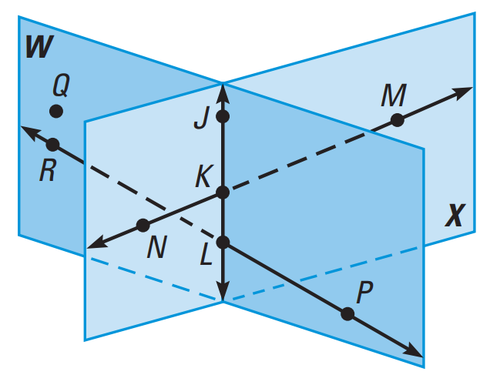
2.) Points Q, J, and M are collinear.

3.) Points K, L, M, and R are coplanar.

4.)$\overset{⃡}{MN}$ and $\overset{⃡}{RP}$ intersect.

5.) $\overset{⃡}{RP}$ ⊥ plane W.

6.) $\overset{⃡}{JK}$ lies in plane X.

7.) ∠PLK is a right angle.

8.) ∠NKL and ∠JKM are vertical angles.

9.) ∠NKJ and ∠JKM are supplementary angles.

10.) ∠JKM and ∠KLP are congruent angles.

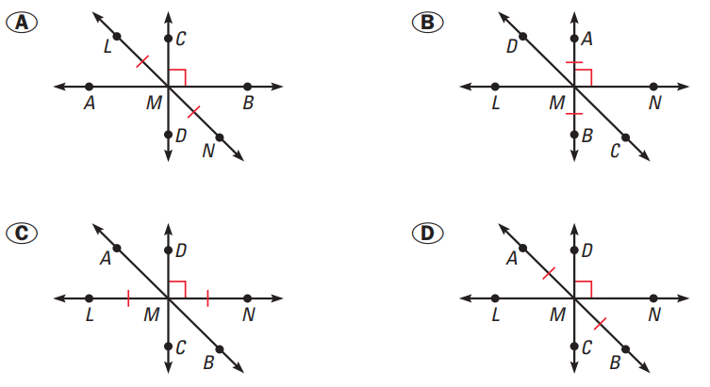
11.) Multiple Choice: Choose the diagram at
right showing $\overset{⃡}{LN}, \overset{⃡}{AB} and \overset{⃡}{DC}$ intersecting
at point M, $\overset{⃡}{DC}$ bisecting $\overline{LN}$, and $\overset{⃡}{DC}$ ⊥ $\overset{⃡}{LN}$.

Decide whether the statement is true or false. If it is false, give a giving a counterexample by sketching a diagram or writing a sentence.

12.) Through any three points, there exists exactly one line. 13.) A point can be in more than one plane.

14.) Any two planes intersect.

15.) Sketch a diagram showing $\overset{⃡}{XY} intersecting \overset{⃡}{WV}$ intersecting at point T, so that$\overset{⃡}{XY}$ ⊥ $\overset{⃡}{WV}$. In you diagram, does $\overline{WT}$ have to be congruent to $\overline{TV}$?

16.) Multiple Choice: Which of the following statements cannot be assumed from the diagram?
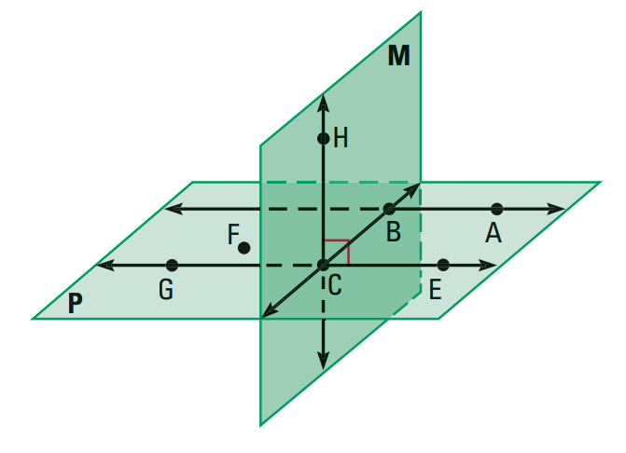
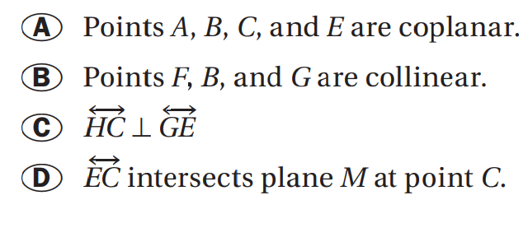

Use the diagram below to write an example of each postulate.

17.) “A line contains at least two points.”

18.) “If two lines intersect, then their intersection is exactly one point.”

19.) “Through any three noncollinear points there exists exactly one plane.”

